LAB 1.1 12/02/25

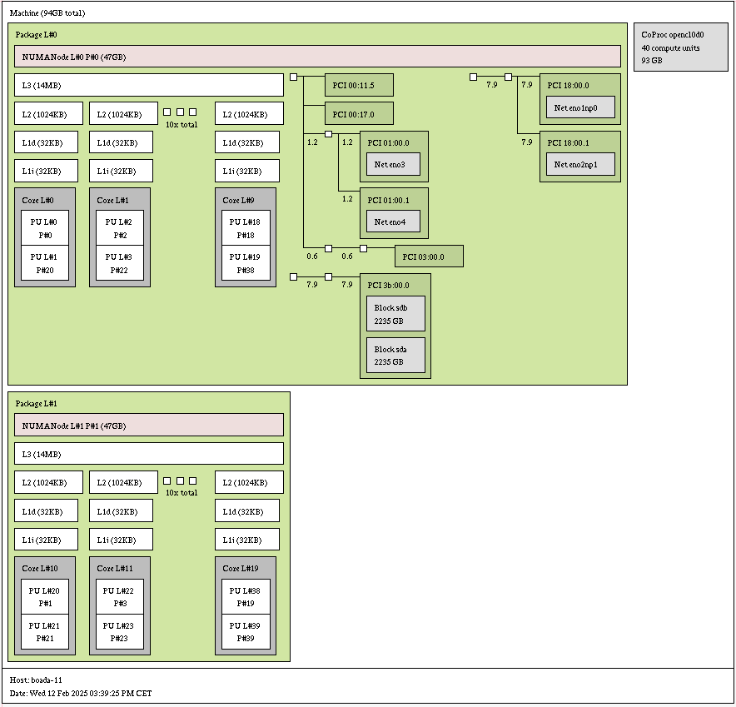

| Characteristic | Value |
| --- | --- |
| Number of sockets per node | 1 |
| Number of cores per socket | 10 |
| Number of threads per core | 2 |
| Maximum core frequency | 3200 MHz |
| L1-I cache size (per-core) | 32 KB |
| L1-D cache size (per-core) | 32 KB |
| L2 cache size (per-core) | 1024 KB |
| Last-level cache size (per-socket) | 14 MB |
| Main memory size (per socket) | 47 GB |
| Main memory size (per node) | 47 KB |

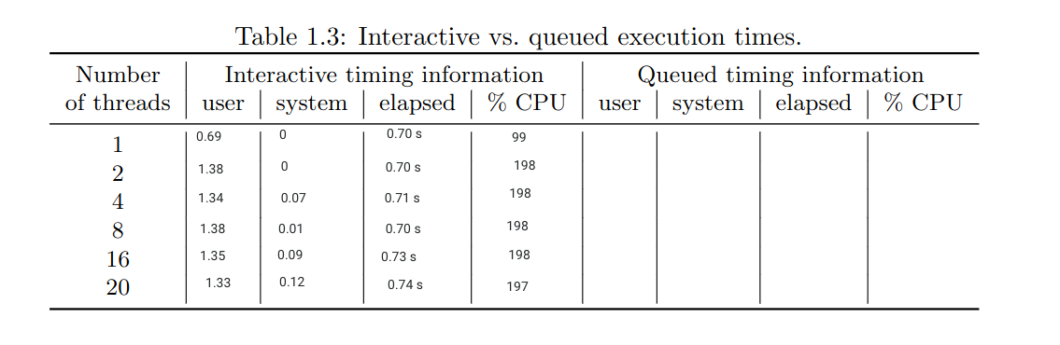

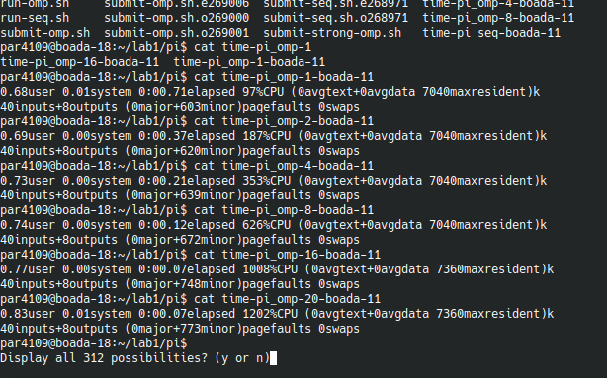

20

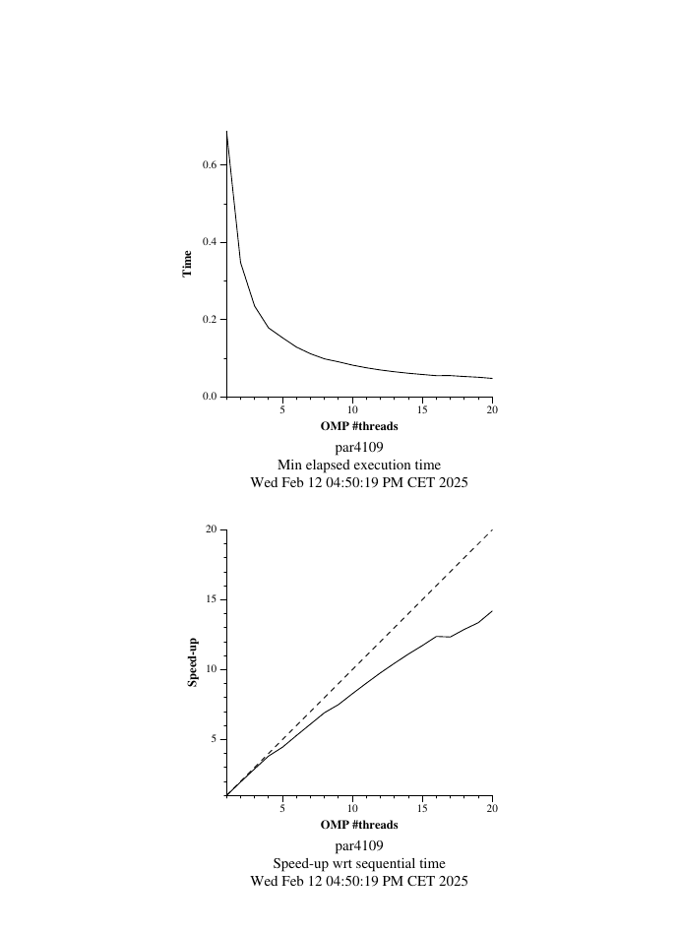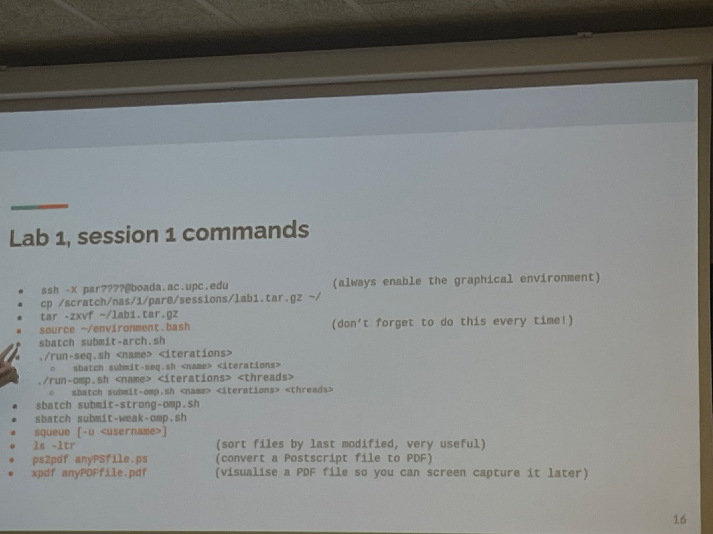

40

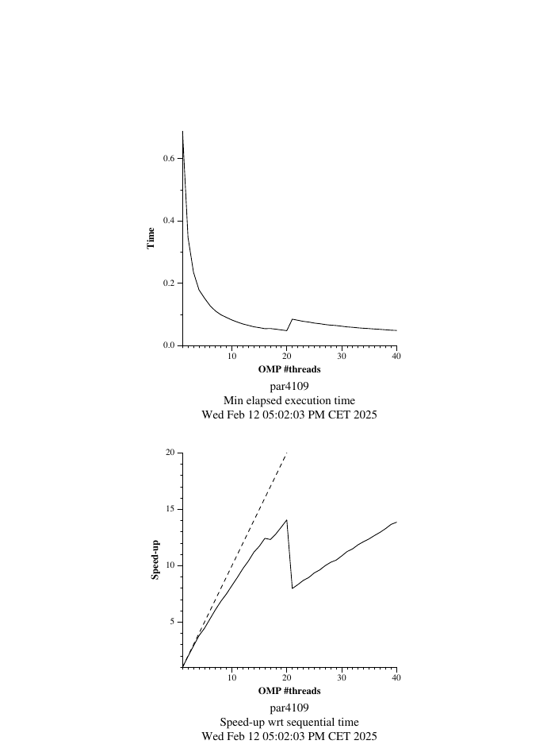

weak

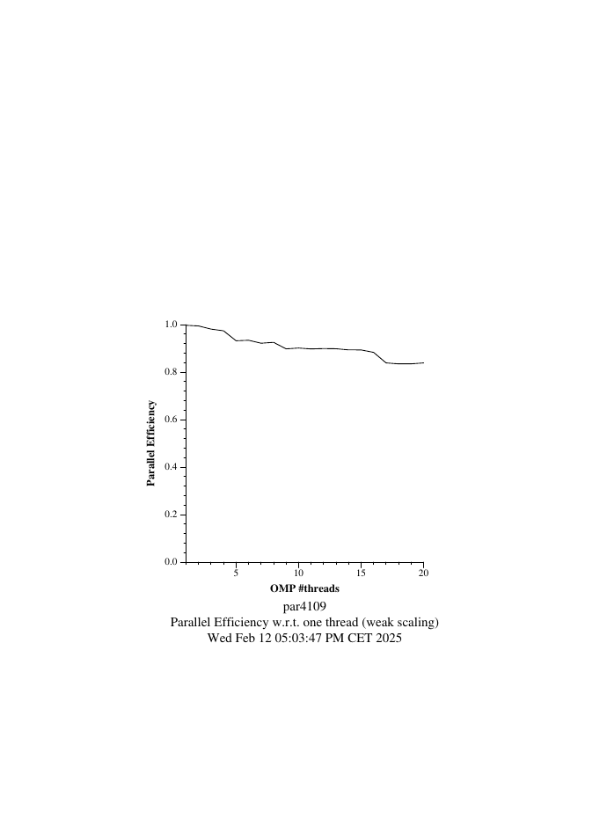

LAB 1.2 19/02/25

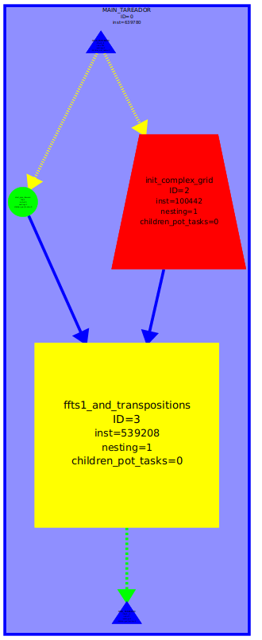

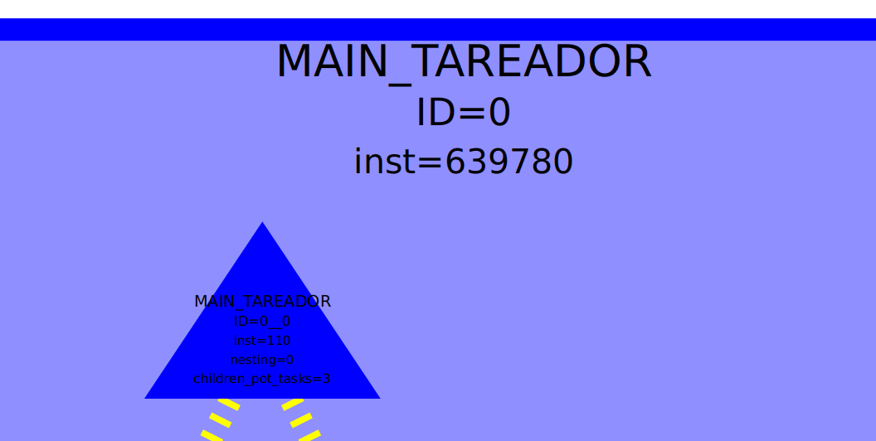

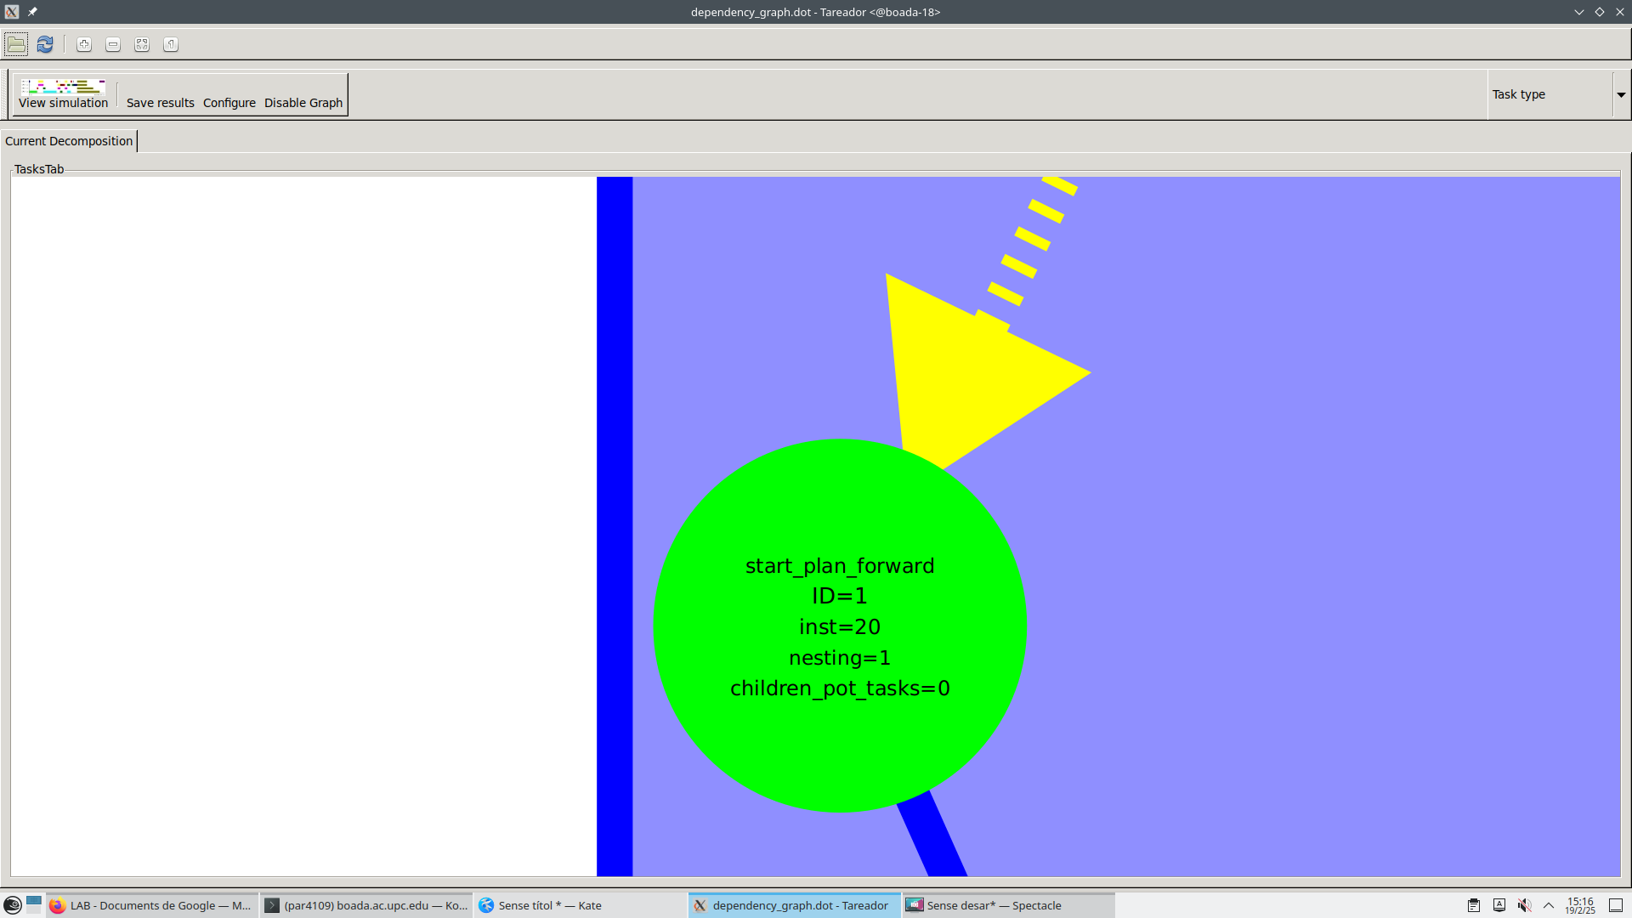

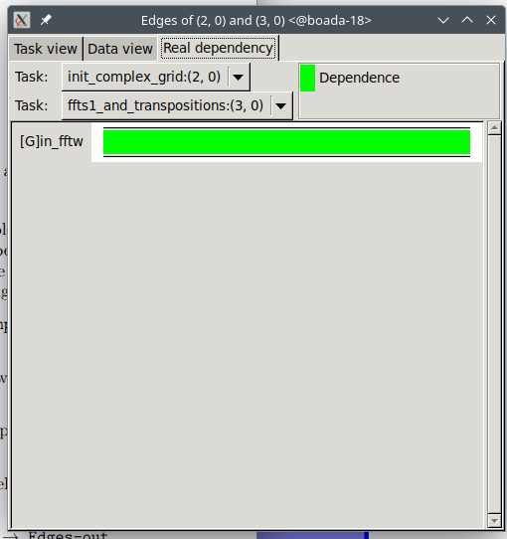

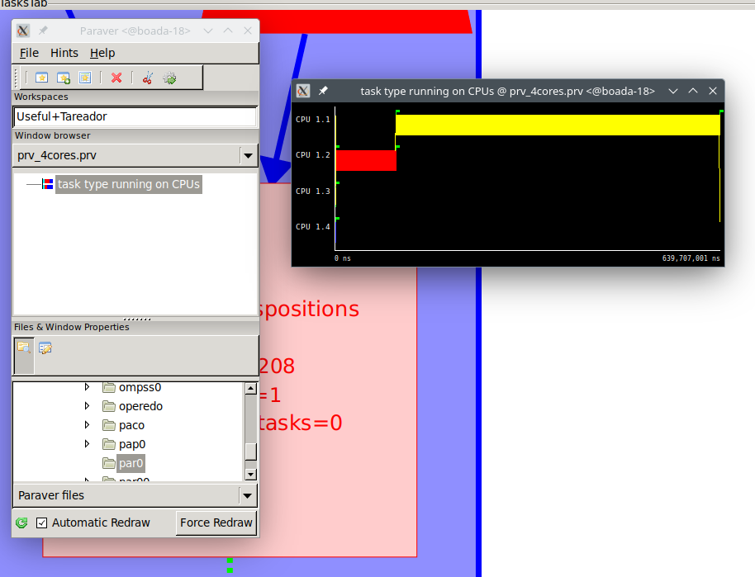

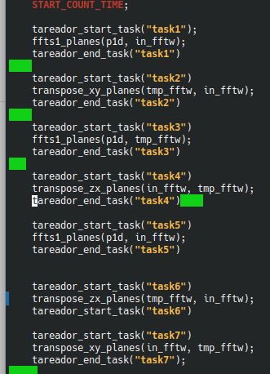

Modificaciones

| Version | T1 | Tinf | Par (T1/Tinf) |
| --- | --- | --- | --- |
| seq | 639780 | 639760 | 1.00003 |
| V1 | 639780 | 639760 | 1.00003 |
| V2 | 639780 | 361525 | 1.77 |
| V3 | 639780 | 155065 | 4.126 |
| V4 | 639780 | 64750 | 9.88 |
| V5 | 639780 |  |  |

FOTOS

V1

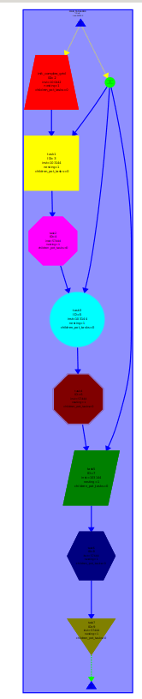

V2

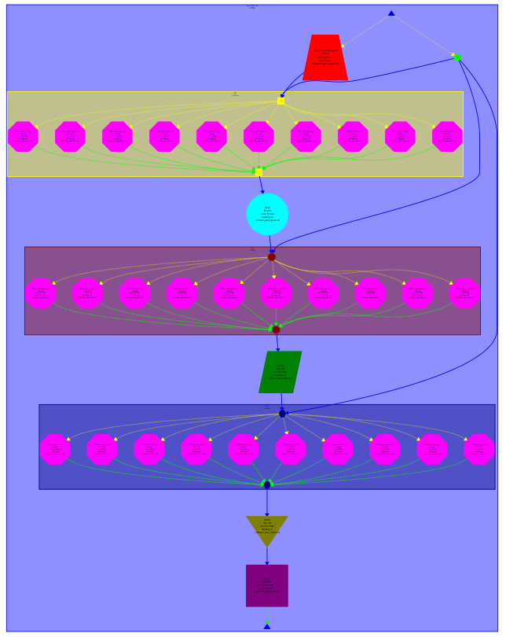

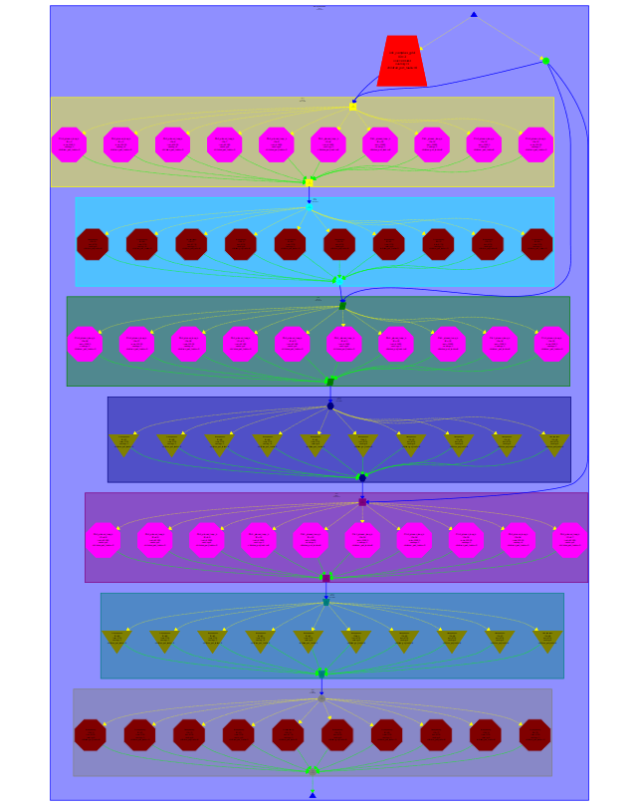

LAB 1.3

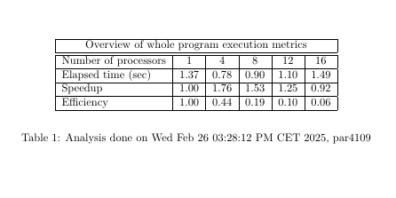

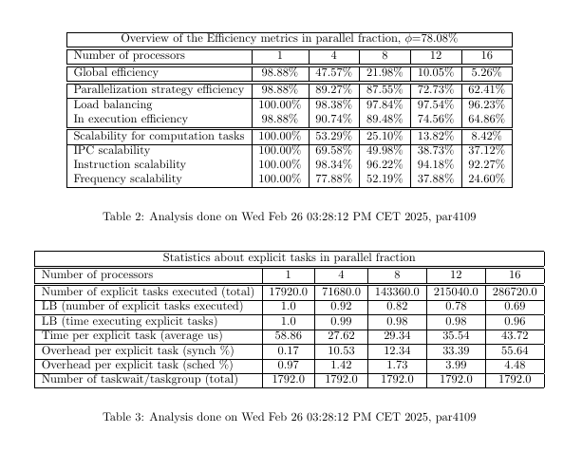

* What is the information that you can see in the tables generated by Modelfactors? How can you use it?
* Is the scalability appropriate?
* Is the overhead due to synchronisation negligible?
* Does this overhead affect the execution time per explicit task?
* Which is the parallel fraction, i.e. value of φ, for this version of the program?
* Is the efficiency of the parallel regions appropriate?
* Which factor is negatively influencing the most?

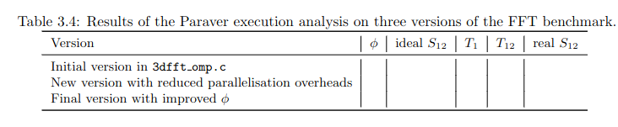

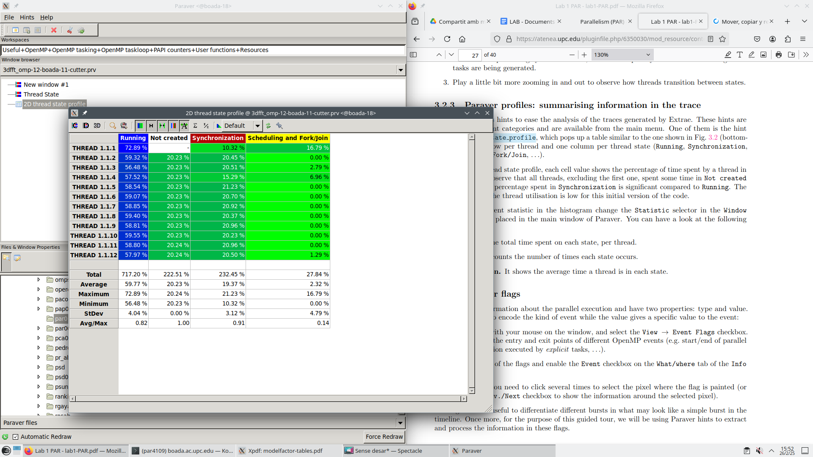

VERSION 2 de descomentar

